 | 5.1.5 Topbar and Statusbar - Help menu
Table of content
Help Menu 1
Manual 1
Release Note 1
Bforartists Website 1
Quickstart Learning Videos 1
Report a Bug 1
Blender Python API reference 1
Save System Info 1
Splash Screen 2

Help Menu

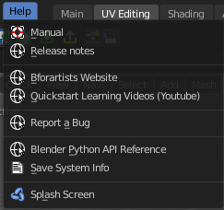
The Help menu contains some external links to useful resources. In this menu you can also find a utility to save the system information and to show the splash screen.

Manual
Opens the Bforartists Manual page in a web browser.

Release Note
Opens the Bforartists Release note page in a web browser.

Bforartists Website
Opens the Bforartists page in a web browser.

Quickstart Learning Videos
Opens the Bforartists Quickstart Youtube channel where you can find the Quickstart tutorial learning videos.

Report a Bug
Report a bug. The link leads you to GitHub. You need to create a GitHub. account to be able to report a bug.

Blender Python API reference
Opens the Blender Python API reference page in a web browser.

Save System Info
Save your system informations to a text file.

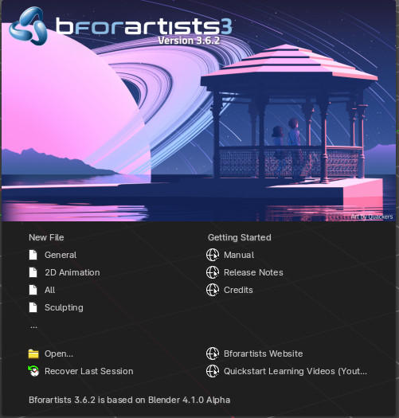
Splash Screen
Reveals the Splash Screen.

